Task 2 — Motor Control with PWM & Obstacle Detection
Objective
The objective of this task is to control the motion of a motor using pulse signals (PWM concept) and automatically stop the motor when an obstacle is detected using an ultrasonic distance sensor. This demonstrates basic automation logic used in robotics and smart systems.
Component Used
- Arduino UNO
- HC-SR04 Ultrasonic Sensor
- A4988 Stepper Motor Driver
- Bipolar Stepper Motor
- Jumper Wires
- Wokwi Online Simulator
Working Principle
The ultrasonic sensor measures the distance between the sensor and an object by sending ultrasonic waves and calculating the time taken for the echo to return.
The Arduino continuously reads the distance value from the ultrasonic sensor.
- If the distance is greater than 20 cm:
- the motor rotates continuously
- If the distance is less than 20 cm:
- the motor stops automatically
Motor speed is controlled using pulse timing (Pulse Width Modulation concept)
Code
#define trigPin 9
#define echoPin 10
#define stepPin 3
#define dirPin 4
long duration;
int distance;
void setup() {
Serial.begin(9600);
pinMode(trigPin, OUTPUT);
pinMode(echoPin, INPUT);
pinMode(stepPin, OUTPUT);
pinMode(dirPin, OUTPUT);
digitalWrite(dirPin, HIGH);
}
void loop() {
digitalWrite(trigPin, LOW);
delayMicroseconds(2);
digitalWrite(trigPin, HIGH);
delayMicroseconds(10);
digitalWrite(trigPin, LOW);
duration = pulseIn(echoPin, HIGH);
distance = duration * 0.034 / 2;
Serial.print("Distance: ");
Serial.println(distance);
if(distance < 20) {
Serial.println("Obstacle detected - Motor stopped");
delay(500);
}
else {
for(int i=0;i<200;i++) {
digitalWrite(stepPin, HIGH);
delayMicroseconds(800);
digitalWrite(stepPin, LOW);
delayMicroseconds(800);
}
Serial.println("Motor running");
}
}
Serial Monitor Output
Distance: 45
Motor running

Distance: 18
Obstacle detected - Motor stopped
Circuit Diagram
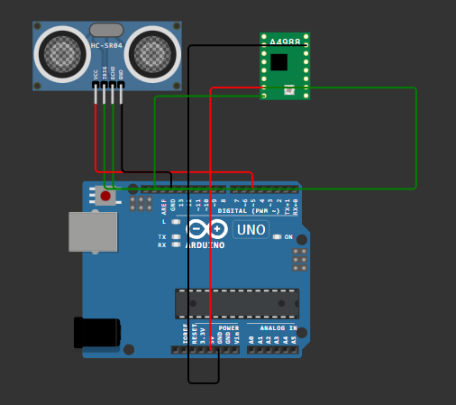
Result
The motor control system was successfully implemented using ultrasonic sensor input. The motor rotated when no obstacle was detected and stopped automatically when an object came within the threshold distance. The system demonstrated correct PWM-based motor control and sensor-based automation logic.

